LAB2 Report

成員:陳俊惟 , 黃秉茂 , 蔡承恩 , 李京叡

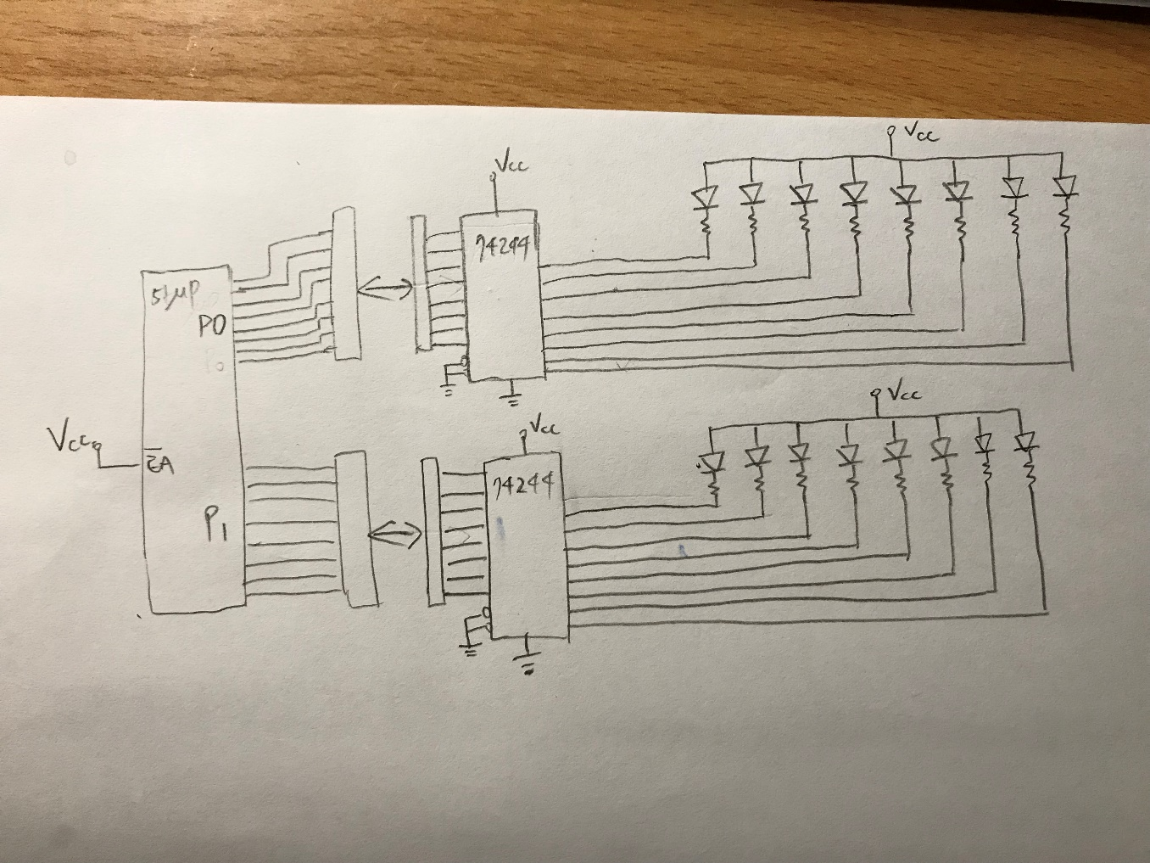

51up, jumper, 74244, LED連接方式如圖，51up上有兩個port : P0,P1，分別透過兩個jumper與兩個74244IC連接，74244的作用為資料同步，分別控制上下兩排LED燈，控制方式與lab1相同。74244輸出的8隻腳分別連接1個LED燈，當輸出為Low時，會與Vcc產生電位差，驅使LED燈亮，因此透過51up控制74244輸入訊號，改變LED開關，例如:輸出11110111，則第5個LED燈亮，其他暗，因此假如要使下排呈現前4個LED亮，後4個LED暗，則要控制51up

輸出P1=00001111，其他情況以此類推。

code:

org 0

mov sp, #50H

clr c

mov a, #0ffH ;store 00000000 at R7

mov R7, a

mov a, #0fH ;00001111

mk1:

cpl a

mov r6, a

mov p1, A

mov a, r7

mov p0, a

call delay

rlc a

mov r7, a

mov a, r6

jc mk1

mov a, #0ccH

mk2:

cpl a

mov r6, a

mov p1, a

mov a, r7

mov p0, a

call delay

rrc a

mov r7,a

mov a, r6

jc mk2

mov a, #0f0H

mk3:

cpl a

mov r6, a

mov p1, a

mov a, r7

mov p0, a

call delay

rlc a

mov r7, a

mov a, r6

jc mk3

mov a, #33H

mk4:

cpl a ; XXX

mov r6, a

mov p1, a

mov a, r7

mov p0, a

call delay

rrc a

mov r7,a

mov a, r6

jc mk4

mov a, #0fH

jmp mk1

delay:

push 5

push 6

push 7

mov r5, #10

dd1:

mov r6, #250

dd2:

mov r7, #200

djnz r7, $

djnz r6, dd2

djnz r5, dd1

pop 7

pop 6

pop 5

ret

end

code description:

we assume the p0 is upper led(U_L)

assume the p1 is lowwer led(L_L)

r6 store the information of p1

r7 store the information of p0

basing on our code(rewrite):

mark1 is as the phase1:

only one led of L_U would shining from the right to left

U_U's led would shinging

as following 00001111 or 11110000 (0's mean on, 1's means off);

mark2 is as the phase2:

only one led of L_U would shining from the left to right

U_U's led would shinging

as following or 11001100 00110011 (0's mean on, 1's means off);

mark3 is as the phase3:

only one led of L_U would shining from the left to right

U_U's led would shinging

as following 00001111 or 11110000 (0's mean on, 1's means off);

mark4 is as the phase4:

only one led of L_U would shining from the right to left

U_U's led would shinging

as following 00110011 or 11001100 (0's mean on, 1's means off);

each mark would call "delay", casuing almost 0.1 seconds delay(10*250*200*0.2*0.000001)

markI change to markJ would depend on r7's information(carry is 0 or not) {J = (I+1)mode 4}

tips: Because only a can move to p0 or p1, we would store information differently in r6 and r7

**circuit-drivers interactions**

information of 0 would let led turn on(generating Potential difference)

inforamtion of 1 would let led turn off

we connect 2 8-bits lines to connect port0-upperled, port1-lowwerled, and deliver the information of code to led, to display our result

LabWork conducting

* difficulties encountered and resolving measures:

依照Lab2的流程step-by-step，把程式寫進板子後，LED燈號左右和上下的方向不太對，後來透過改code的port的參數順序和接線就解決了，左排的插孔是上排，右排的是下排。接下來發現phase 4燈號的初始狀態不太對，一開始的on 和 off 是反過來的，發現應該是code內phase 4的初始值給錯，調整之後就正常多了。

* phenomena observed and explanations

在這一次的lab中，發現delay是透過呼叫沒在做事的instruction很多次以達成，每個instruction都需要時間，所以執行很多次便會造成delay。如果讓delay調成0，就會因為燈號閃爍太快，看起來就會一直全亮，所以要用delay確認是反有bug。也發現djnz 0的話，會變成FFH而不是-1，所以會執行很多次，djnz 1才是只執行一次。

self-evaluation

* things learnt

由於上次的LAB1已經將這個軟體大致搞清楚了,所以我們這次就可以上手的很快,也能夠快速地找到CODE裡面需要調整的部分

* retrospections raised to oneself

其實我們原本只能懂得大概,但經過LAB的自行摸索後,漸漸地自己領悟出了一些原理,像是delay 若小於零的話 ,則會變成原本的最大值(ex:假設原本4bit , -1🡺FFFF),自我學習雖然一開始會摸不著方向,但若找到法門,則成效絕非按部就班的學習能夠趕上的

在LAB2結束後,我們有再多加的研究電路板上的其他的顯示器,像是下一次實驗的七段顯示器,我們已經可以順利的表達所有數字,其中由於0為高電位,故要顯示一個數字就必須給他本身二進制的補數就可表達出來